



SIGILS Project

Technical Documentation of rendering

Alejandro Hijano – CTO

# 

Project Resume 3

Summary of graphical fidelity techniques applied currently 5

Dynamic Procedural Story Generation 6

# Project Resume

* Genre: VR Roguelike Action Sandbox RPG
* General concept:
  + The player in the skin of an outcast is transported to a high fantasy world (The world while it maintains a beautiful aesthetic and stunning landscapes, it contrast with the many concepts more proper for a dark fantasy that plague the world).
  + The world has its own stories and events and the player can choose how to intervene and how or simply ignore them and pursue its own power to see how far it can go.
  + After a predetermined time the player will be challenged by a special NPC, that shares similar characteristics with the player.
  + Each Run it is unique due to the procedural story generation that determines the objectives of the NPCs + how the events unfold and how the player affects them.
* Systems:
  + Dynamic Story System that evolves with the important events of the (the player kills an important character; a village is destroyed by a mage, etc.).
  + Dynamic Magic System by “runes”, medieval melee and distance combat inspired in Blade & Sorcery.
  + Light Survival Mechanics (hunger thirst sleep inventory weight).
  + A more traditional magic system for more fast-paced magic warfare.
  + The Dynamic Magic System allows to enchant wands and staffs to be able to cast spells Noita Wand style.
  + The AI uses the objectives generated by the dynamic story to drive its behaviour.
  + The Dynamic Story System generates the story of the world by factions, simulating encounters between faction leaders and important events using templates and variables.
  + The world evolves dynamically with the consequences of the actions of the player and the NPCs. The player is not the only force of change in the world or the most important.
  + Pain System by levels that simulates in a realistic manner the effects of wear and injury in combat in the character. Its hard-core but not hard-core enough that would destroy the experience
  + Grimoire System that handles all the “runes” and spells the player know (When the player uses one spell/rune for 1st its determined that he knows it).
  + The NPC that invades the world to challenge the player, the Challenger, is of similar characteristics of the player and he is aligned with the faction that hates the most the player, neutral if no one hates the player enough.
  + Locational Damage System for all limbs and torso.
  + Armour system inspired in Blade & Sorcery.
  + “One-shot protection”, System that makes the player unable to die from a single damage instance, giving them chances at all times, it still allows the player to die from more damage instances after the first one received and it resets on full heal.
  + Dynamic Elemental Element System that allows the environment to interact with different elemental elements (Inspired in Divinity Original Sin 2).
  + Reputation System based in the actions of the player towards the other factions and its consequences.
  + All the significant actions related to something important have values that interact with the Dynamic Story System.

# Summary of graphical fidelity techniques applied currently

*[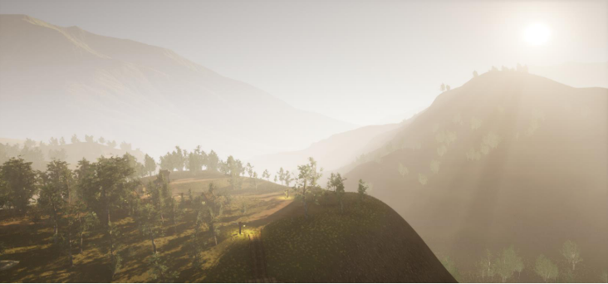](https://youtu.be/dqAJ4JY_S-I)The Look and feel of the whole Project is subject to changes, this is just a test of technical capabilities.* Click on the image to see video demostration.

* Completely Dynamic Illumination, (cascade shadows, 4 cascades close and 4 far shadow cascades).
* Distance Field Shadows, global and mesh contributing to all the long distance shading and improving quality of the shadows.
* Landscape of 4 km^2 made with TerreSculptor, divided with World Composition with level streaming determined by distance to the player (pieces of the landscape load similar on how The Elder Scrolls 5 Skyrim does it on it’s open world).
* Day/Night cycle that updates on each frame for really smooth transition on the lightning and shadows.
* Deep Learning Super Sampling implementation to keep framerates high.
* Volumetric Lightning by the extensive use of volumetric height fog.
* High resolution textures on ground by the use of runtime virtual texture technology that is also used to automatically place all the small foliage and stones with the use of a splatmap.
* With the RTV, it’s on use a splatmap that tells the landscape material where to paint all the textures and where to place all the small foliage + extra layers on the landscape material to allow for manual changes on it.
* Streaming Virtual Textures implemented for everything other than the trees and the landscape itself for performance gains versus standard texture methods.
* All the foliage is animated from the material and controlled from a single material parameter collection that controls the intensity and the direction of the wind, right now it affects everything by the same setting and that is a limitation of its current implementation. Dynamic Procedural Story Generation
* Dynamic Procedural Story Generation elements:
  + Historic Entities
  + Historical events
  + The underlying logic that binds everything together
  + The exposition to the player of the story
  + The change and evolution of story with the action of the player and the NPCs.
* Historic Entities:
  + They are set by the default narrative pre generation; they contain the names properties personalities and an archetype. They are also places not just characters.
* Historical Events:
  + They are templates that by the use of variables and the historic entities, they determine the changes in relations and objectives of the NPCs.
* Underlying logic that binds everything together:
  + In truth, there is no logic, the story is a chronology of random events selected by various parameters within the Historic Entities, then in the exposition of the events with the use of a rich text we create *apophenia* (is the tendency to perceive meaningful connections between seemingly unrelated things, we deliberately force this effect with the rich text in the templates).
* Exposition to the player:
  + The events are exposed to the player with conversations with NPCs y/o text written on various mediums that reflect the events resolved with the correct variables in a coherent manner.
* Change and evolution of the story:
  + All action that causes change in a historic entity will be registered and the variables will be updated by the changes brought by the action done. Some of these events can become historic events on themselves which their variables will be updated in real time by the perpetrators (NPCs or Player).